# PeopleSafe - Health Reimbursement Account (HRA)

What is an HRA (Health Reimbursement Account)?

Determining Nature of HRA Call

HRA Account Balance RxClaim

HRA Copays RxClaim

HRA Disclaimers

HRA Disputes

Related Documents

**Description:** How to view HRA (Health Reimbursement Account) information.

|  |
| --- |
| What is an HRA (Health Reimbursement Account)? |

With an HRA, the member will have funds stored in an account (sometimes accessible with a debit card) that can be spent on eligible medical and/or prescription expenses. The funds are tax-exempt and provided by the employer. Once the funds in the HRA have been exhausted, the member will be responsible for paying subsequent out of pocket costs.

HRA’s are client specific. It is the employer’s decision whether or not to offer an HRA, and how much to provide in each employee’s account. HRA’s can be at the Individual or Family level, and may be shared between medical and prescription expenses, also known as an “integrated” HRA. HRA’s can be maintained by the PBM or by other companies, who would then send us files detailing the amounts contributed to and deducted from the account.

Members with HRAs may also have a [High Deductible Health Plans (HDHP) (038546)](https://thesource.cvshealth.com/nuxeo/thesource/#!/view?docid=91ada5ca-68dd-4fcf-a6a4-a13b33923759).

 HRA funds (debit card or account) are debited automatically for the cost of the prescription. The only way to not use these funds is to **not** have the claim processed through the insurance.

HRAs (Health Reimbursement Accounts) may have a debit card associated with their account or the account may be directly debited. The HRA (debit card or account) will pay for their medications until the funds have been depleted.

The HRA is visible to Customer Care on the Account Balance screen, Client Financials screen for a paid claim or the Details screen for a test claim

 These types of calls should not be transferred to the Senior Team unless the member specifically request to escalate the issue.

Top of the Document

|  |
| --- |
| Determining Nature of HRA Call |

Perform the following steps:

|  |  |  |
| --- | --- | --- |
| **Step** | **Action** | |
| **1** | Determine the reason for the call: | |
| **If the member is asking…** | **Then…** |
| * How much do I have in my HRA account? * What is my current balance? * Why is that my current balance? * Which claims have been applied to my HRA? | Refer to HRA Account Balance RxClaim. |
| * Why did I pay a copay for this prescription? * Why wasn’t my HRA used to pay for this prescription? | Refer to HRA Copays RxClaim. |
| That cannot be right. I should still have money left in my HRA. | Refer to HRA Disputes. |

Top of the Document

|  |
| --- |
| HRA Account Balance RxClaim |

Perform the following steps to research the HRA balance for an RxClaim member:

|  |  |
| --- | --- |
| **Step** | **Action** |
| **1** | On the Main screen, click the **Account Balance** tab to access the Account Balance screen.  **Note:** This screen displays all HRA accounts managed by the PBM under Account Class field.   * **Accumulated Amount** displays how much of the HRA has been used. * **Limit Amount** displays the total amount of funds that were initially available. * **Remaining Amount** displays the amount left in the HRA account * **Integrated Benefits** indicates whether the accumulations for that time period are integrated with medical benefit accumulations and whether the benefit has been met or not. |
| **2** | Select the **radio button** next to the HRA account to view, then click on the **View Balance Details** button (to view Account Balance of HRA).  **Note:**  The View Balance Detail screen displays all paid claims accumulating under each of the HRA accounts for a specific timeframe. Medical claim transactions will also be included if the HRA is shared between prescription and medical benefits. |
| **3** | Click on **Details** link to view the accumulation breakdown amount of each claim.  **Note:** The Line-Item Accumulation Details pop-up screen displays the breakdown of the amount that has been applied to HRA account, as well as other accumulators such as deductible, maximum out-of-pocket, etcetera. |
| **4** | Explain to the member the current balance in their HRA account. |

Top of the Document

|  |
| --- |
| HRA Copays RxClaim |

Perform the steps below when researching the member HRA copay status:

|  |  |
| --- | --- |
| **Step** | **Action** |
| **1** | On the Main screen, click on the prescription number of the desired claim to access the Prescription Details screen. |
| **2** | On the Prescription Detail screen, click on the **View Client Financials** button to access the Financial Detail Screen.  **Note:** The **Client Financials** screen displays the breakdown of the amount applied to the HRA account.   * This information is only displayed for HRA’s managed by the PBM. If the claim used HRA dollars from multiple years, a hyperlink will be displayed on the amount. Click the hyperlink to view a pop-up window detailing the HRA amounts applied from each year. |
| **3** | Explain to the member the HRA contribution amount.   * If no HRA funds were applied to the claim, refer to HRA Account Balance RxClaim to determine if the member has any funds remaining in their HRA and advise accordingly. |

Top of the Document

|  |
| --- |
| HRA Disclaimers |

The following disclaimer about Health Reimbursement Accounts will be displayed on the Prescription Refill Summary, MChoice Transfer and MChoice Retail to Mail Transfer screen (OMS) screens:

“HRA contributions are calculated based on a single claim transaction. The amount due is subject to change after processing.”

This disclaimer indicates that the member’s available HRA funds will be calculated into the Amount Due/Participant Pay fields on these screens. However, the cost is factored into each claim on an individual basis, not the order as a whole, and may change after processing is complete.

**Example:**

A member orders three prescriptions, each with a $10 copay. The member has $25 left in their HRA account. The Prescription Refill Summary will show $0 copay for all three prescriptions since each is calculated separately based on the $25 left in the member’s HRA. However, once the order processes the member will owe $5 because the total order cost is $30, but only $25 was left in the member’s HRA.

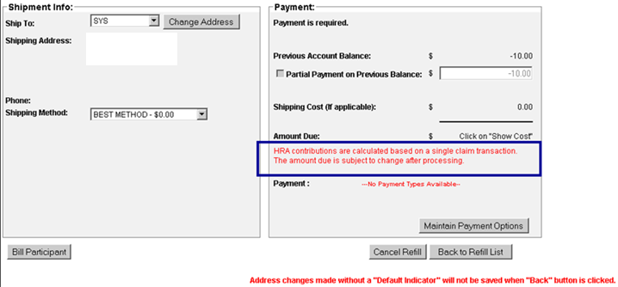

**Refill Summary Screen**

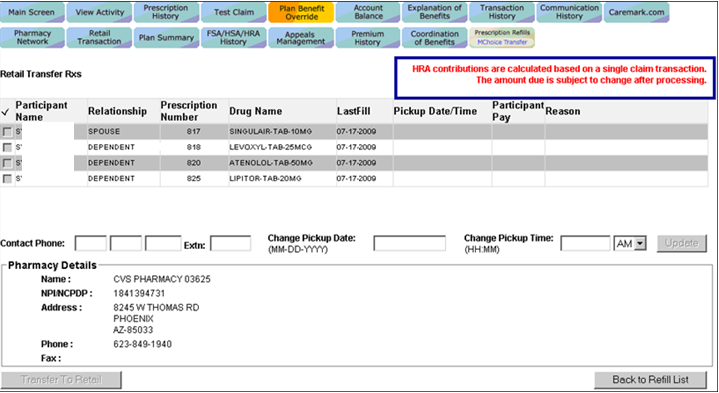

**MChoice Transfer Screen**

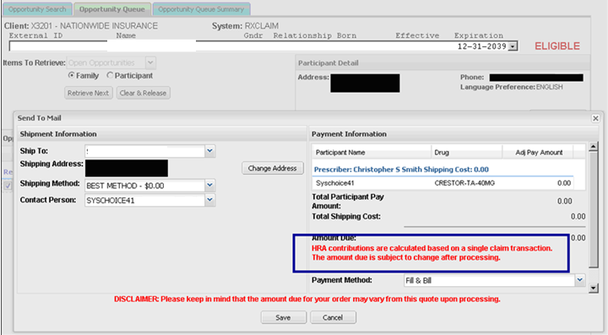

**MChoice Retail to Mail Transfer screen (OMS)**

Top of the Document

|  |
| --- |
| HRA Disputes |

When the member does not agree with the balance in their HRA account, perform the steps below:

|  |  |  |
| --- | --- | --- |
| **Step** | **Action** | |
| **1** | Perform the steps documented in the HRA Account Balance RxClaim section. | |
| **2** | Explain to the member which claims paid against the HRA balance, including any medical claims if the HRA is integrated. Provide details as necessary following the [HIPAA Grid (028920)](https://thesource.cvshealth.com/nuxeo/thesource/#!/view?docid=5b354e50-0d15-42d0-b9c2-0711ea02d9ce). | |
| **If…** | **Then…** |
| The member’s dispute is valid (where a claim is processed incorrectly against the HRA, prescription never received/lost in transit, etcetera) | Refer to the CIF for client-specific instructions or if no client-specific instructions are noted in the CIF, send an Account Executive Task as per guidelines noted in the [Account Executive Consideration Task (AE Task) (027240)](https://thesource.cvshealth.com/nuxeo/thesource/#!/view?docid=497dcdb2-2c97-4a3a-afe9-1fa95f6dd734) |
| A prescription was processed through the insurance and the HRA was used to pay for the claim but should not have been | The pharmacy would need to reverse out the claim and reprocess without using the insurance. |
| The member is disputing a medical claim | Refer to the CIF for client-specific instructions and/or refer member to the medical provider as appropriate |

Top of the Document

|  |
| --- |
| Related Documents |

[Log Activity/Capture Activity Codes (005164)](https://thesource.cvshealth.com/nuxeo/thesource/#!/view?docid=bdac0c67-5fee-47ba-a3aa-aab84900cf78).

[Customer Care Abbreviations, Definitions, and Terms Index (017428)](https://thesource.cvshealth.com/nuxeo/thesource/#!/view?docid=c1f1028b-e42c-4b4f-a4cf-cc0b42c91606)

[Billing & Payments Index (049663)](https://thesource.cvshealth.com/nuxeo/thesource/#!/view?docid=be58f9e6-2fde-4398-bce1-6f862189f89c)

**Parent Document:** [CALL 0049 Customer Care Internal and External Call Handling](https://policy.corp.cvscaremark.com/pnp/faces/DocRenderer?documentId=CALL-0049)

Top of the Document

Not To Be Reproduced or Disclosed to Others Without Prior Written Approval

**ELECTRONIC DATA = OFFICIAL VERSION / PAPER COPY = INFORMATIONAL ONLY**